**Zadania do ćwiczenia nr 17**

**Wyznaczenie rozkładu temperatury w pręcie**

Celem ćwiczenia jest zapoznanie się z rozkładem temperatury w pręcie w warunkach konwekcji swobodnej i wymuszonej.

Instrukcja do ćwiczenia tutaj: <http://fluid.itcmp.pwr.wroc.pl/~epol/dane/Wymiana%20ciepla/lab/cw17.pdf>

Film instruktażowy do ćwiczenia do pobrania stąd:

<https://drive.google.com/drive/folders/181WHKn-If3rdLaEi-49JBWiQPLhua2N1?usp=sharing>

Dane pomiarowe są tutaj:

Lambda pręta ( mosiądz)= 90 W/(mK)

Fi zewn=12 mm

Fiwew=9,5mm

|  |  |  |  |  |  |  |  |  |  |
| --- | --- | --- | --- | --- | --- | --- | --- | --- | --- |
|  |  |  |  |  |  |  |  |  |  |
|  |  | temperatura otoczenia 18 oC | | | | | | |  |
|  |  | odległość pomiedzy punktami - 1 cm | | | | | | |  |
|  |  | konwekcja swobodna | | |  | konwekcja wymuszona | | | |
|  |  | lp | temp.ot. 18 oC | |  | lp | temp. ot.18 oC | |  |
|  |  | pierwszy punkt- -1 | 165 |  |  | pierwszy punkt--1 | 104 |  |  |
|  |  | 2 | 153 |  |  | 2 | 92 |  |  |
|  |  | 3 | 135 |  |  | 3 | 77 |  |  |
|  |  | 4 | 124 |  |  | 4 | 65 |  |  |
|  |  | 5 | 110 |  |  | 5 | 55 |  |  |
|  |  | 6 | 102 |  |  | 6 | 47 |  |  |
|  |  | 7 | 95 |  |  | 7 | 43 |  |  |
|  |  | 8 | 82 |  |  | 8 | 37 |  |  |
|  |  | 9 | 73 |  |  | 9 | 30 |  |  |
|  |  | 10 | 68 |  |  | 10 | 27 |  |  |
|  |  | 11 | 65 |  |  | 11 | 25 |  |  |
|  |  | 12 | 62 |  |  | 12 | 24 |  |  |
|  |  | 13 | 57 |  |  | 13 | 22 |  |  |
|  |  | 14 | 52 |  |  | 14 | 21,4 |  |  |
|  |  | 15 | 50 |  |  | 15 | 20,5 |  |  |
|  |  | 16 | 45 |  |  | 16 | 20,1 |  |  |
|  |  | 17 | 42 |  |  | 17 | 19,5 |  |  |
|  |  | 18 | 39 |  |  | 18 | 19,3 |  |  |
|  |  | 19 | 37 |  |  | 19 | 19 |  |  |
|  |  | 20 | 35 |  |  | 20 | 18,8 |  |  |
|  |  | 21 | 34 |  |  | 21 | 18,7 |  |  |
|  |  | 22 | 33 |  |  | 22 | 18,7 |  |  |
|  |  | 23 | 32,7 |  |  | 23 | 18,6 |  |  |
|  |  | 24 | 33 |  |  | 24 | 18,8 |  |  |
|  |  | 25 | 33 |  |  | 25 | 18,8 |  |  |
|  |  | 26 | 34 |  |  | 26 | 19 |  |  |
|  |  | 27 | 34,9 |  |  | 27 | 19,2 |  |  |
|  |  | 28 | 35 |  |  | 28 | 19,5 |  |  |
|  |  | 29 | 37 |  |  | 29 | 19,8 |  |  |
|  |  | 30 | 37,3 |  |  | 30 | 20,3 |  |  |
|  |  | 31 | 40 |  |  | 31 | 20,6 |  |  |
|  |  | 32 | 42 |  |  | 32 | 21,7 |  |  |
|  |  | 33 | 45 |  |  | 33 | 22,8 |  |  |
|  |  | 34 | 50 |  |  | 34 | 23,7 |  |  |
|  |  | 35 | 51 |  |  | 35 | 25,3 |  |  |
|  |  | 36 | 56 |  |  | 36 | 27,5 |  |  |
|  |  | 37 | 62,565 |  |  | 37 | 30 |  |  |
|  |  | 38 | 70 |  |  | 38 | 32,5 |  |  |
|  |  | 39 | 75 |  |  | 39 | 36,2 |  |  |
|  |  | 40 | 82 |  |  | 40 | 40,4 |  |  |
|  |  | 41 | 92 |  |  | 41 | 44 |  |  |
|  |  | 42 | 95 |  |  | 42 | 50 |  |  |
|  |  | 43 | 101 |  |  | 43 | 56,5 |  |  |
|  |  | 44 | 117 |  |  | 44 | 63 |  |  |
|  |  | 45 | 134 |  |  | 45 | 80 |  |  |
|  |  | 46 | 141 |  |  | 46 | 120 |  |  |
|  |  |  |  |  |  |  |  |  |  |

Wzory do wykorzystania:

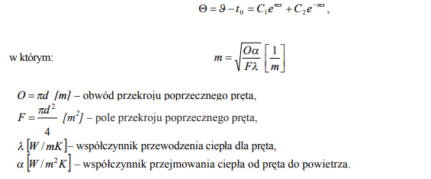

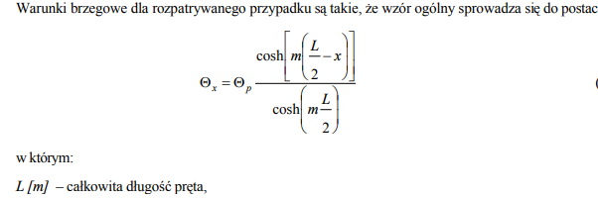

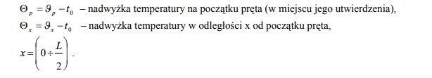

Zadania do wykonania:

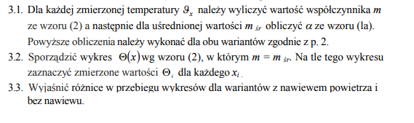

Proszę przesłać wykonane sprawozdanie na moją skrzynkę mailową , zgodnie z wytycznymi uzyskanymi na pierwszych zajęciach.